**VISITOR COUNTER**  USING **ARDUINO**

**Introduction**

In this project, we will make a **Bidirectional Visitor Counter** with an **Automatic Light Control** System using **Arduino**. This project is based on a pair of **Infrared Sensor** that detects interrupt when it detects an **obstacle**. The pair of **IR sensors** can detect the visitor from both directions, i.e. the number of **entering visitors** and the number of **exiting visitors**.  The device counts the total number of people entering through the gate and also the total number of people leaving through the same gate. And finally, it **counts** the **total number of people** currently present inside the room. When no people are inside the room, i.e. the total number of people is zero then the **room light** is turned **off**. When even a single person is found inside the room, the light turns **on**. The light control system is automatic based on the visitors’ presence.

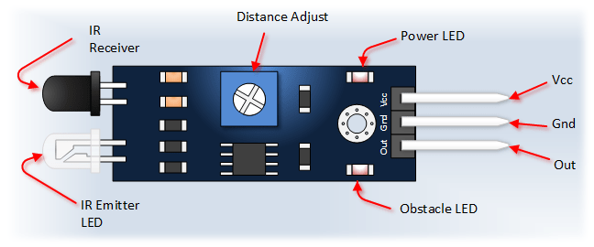

Components

* Arduino Uno
* IR Sensor
* Relay Module
* 16x2 LCD Display
* Breadboard
* Jumper wire

**Application**

This circuit can be used domestically to get an indication of number of persons entering a party

hall, Shopping mall, office, functions in the entrance gate.

Used in industrial automation

In robotics

Home security system

It can also be used at gates of parking areas and other public places

**Objective**

During this activity ,you will help students to achieve following objectives

1. Understanding the principle and operation of ultrasonic distance sensor

2. Design algorithm and flowchart to detect obstacle and get alerted

3. Programming ultrasonic distance sensor using Arduino uno

4. Interfacing ultrasonic distance sensor withArduino uno

**Programming steps**

1. Initialise LCD data input pins and output pin
2. Define relay as output port
3. Initialise counter to 0.
4. When person enters in room ,increase counter by 1
5. Give signal to relay pin
6. Read counter value
7. Check relay pin
8. If counter <0,then output of relay is low,display ‘NOBODY IN ROOM’.
9. If counter >0,then output of relay is HIGH , display count on LCD

**Programming**

  #include<LiquidCrystal.h>

LiquidCrystal lcd(13,12,11,10,9,8);

#define in 14

#define out 19

#define relay 2

int count=0;

void IN()

{

count++;

lcd.clear();

lcd.print("Person In Room:");

lcd.setCursor(0,1);

lcd.print(count);

delay(1000);

}

void OUT()

{

count--;

lcd.clear();

lcd.print("Person In Room:");

lcd.setCursor(0,1);

lcd.print(count);

delay(1000);

}

void setup()

{

lcd.begin(16,2);

lcd.print("Visitor Counter");

delay(2000);

pinMode(in, INPUT);

pinMode(out, INPUT);

pinMode(relay, OUTPUT);

lcd.clear();

lcd.print("Person In Room:");

lcd.setCursor(0,1);

lcd.print(count);

}

void loop()

{

if(digitalRead(in))

IN();

if(digitalRead(out))

OUT();

if(count<=0)

{

lcd.clear();

digitalWrite(relay, LOW);

lcd.clear();

lcd.print("Nobody In Room");

lcd.setCursor(0,1);

lcd.print("Light Is Off");

delay(200);

}

else

digitalWrite(relay, HIGH);

}

**Hardware**

**Instructions**

1. Connect both IR sensors VCC and GND pin to 5V supply voltage and ground pin of arduino.
2. Connect signal out pin of first IR sensor to analog input pin A0 and second IR sensor to analog input pin A5.
3. Make connection of relay such as VCC and GND is connected to arduino board supply and ground
4. Connect signal out pin of relay to digital input pin (D2)
5. Connect pin 3 of LCD to variable resistor and pin 4 to the digital input pin 13(D13)
6. The read/write pin and enable pin of LCD is to be grounded
7. Connect 4,5 ,6,7 pin of LCD to the digital data input pin D11,D10,D9,D8

